Assignment #1. Recursion
Student: Abdulla Islambek
Group: BDA-2505

Objective:
By the end of this assignment, students will be able to:

• Understand the concept of recursion in Java.
• Apply recursion to solve algorithmic problems.
• Implement recursive solutions for arrays, numbers, and strings.
• Improve problem-solving and algorithmic thinking skills.

Rules for Submission:
- The assignment must be completed individually. If you have the same paperwork with other students, you will have 0 to this work.
- The assignment must be submitted by the deadline which is specified in the moodle.astanait.edu.kz. Works submitted after the deadline will not be accepted! To receive a grade, you must submit by deadline and defend your work at practice lesson time.
- IMPORTANT:
  - All tasks must be solved using recursion.
  - Loops (for, while, do-while) are not allowed.
- SUBMIT THE REPORT(DOC FILE) AND THE GITHUB LINK TO YOUR PROJECT. Ensure that the project runs without errors. IN REPORT SHOULD BE:
  - YOUR NAME, GROUP
  - All parts with screens(write part, task and then add screen)
  - Brief summary of your work process

Setup Instructions:
- Install IntelliJ IDEA.The link to download: https://www.jetbrains.com/idea/download
- Create a folder for the project (e.g. assignment1)

Part 1. Recursion with Numbers

Task 1. Print Digits of a Number

Write a recursive function that takes an integer as input and prints every digit of the given number on a separate line.

Example:
Input | Output
5481 | 5  4  8  1

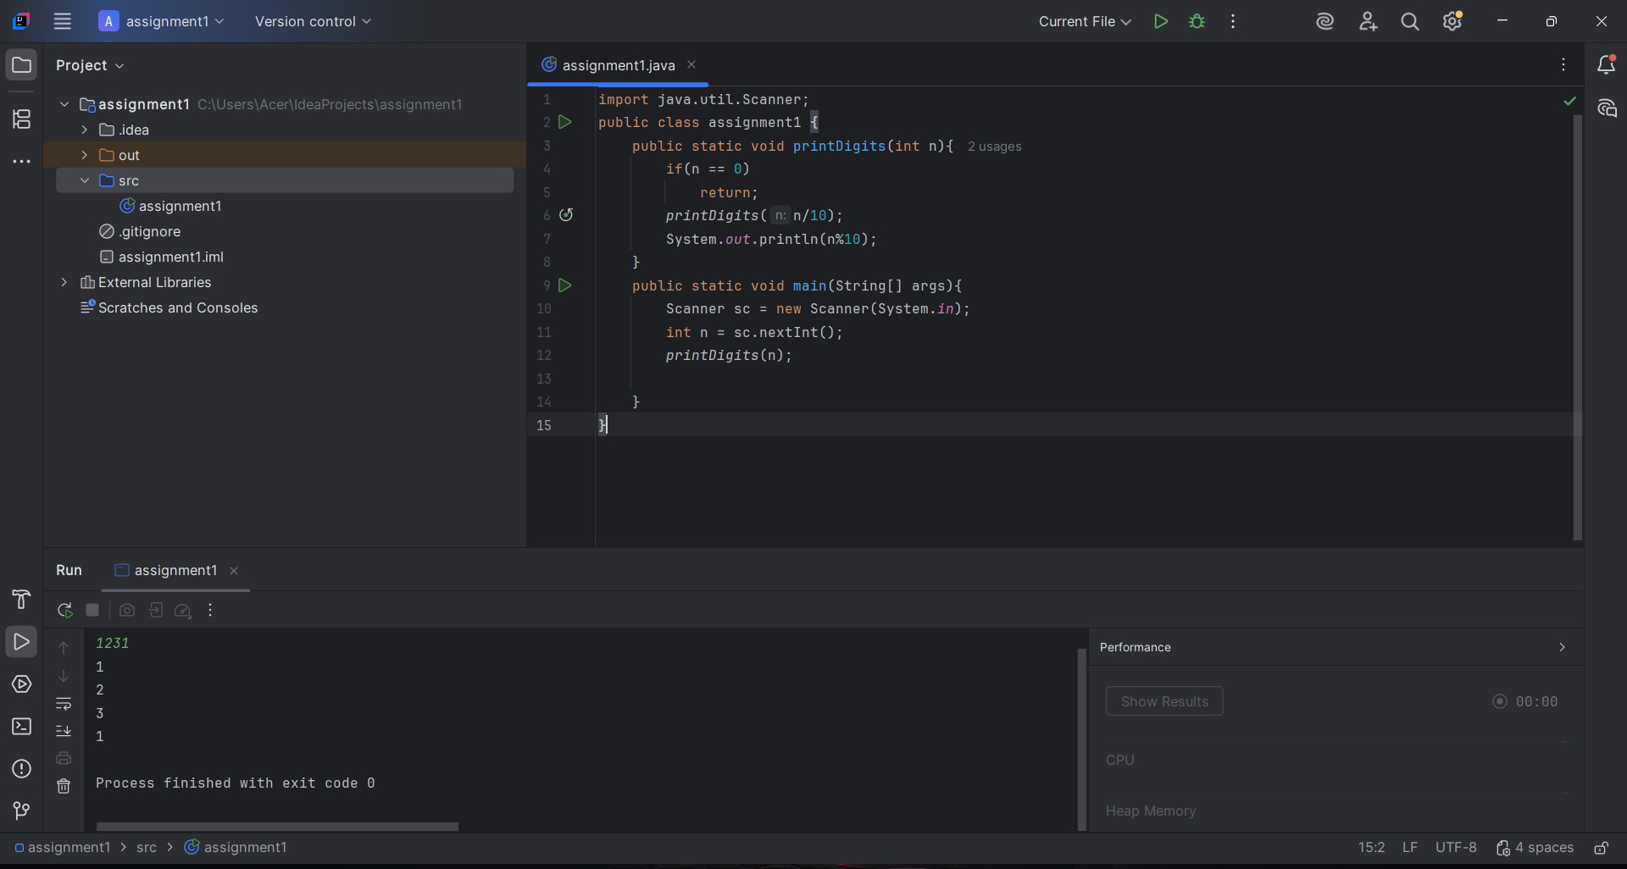

Task 2. Average of Elements

Write a recursive function to calculate the sum of the elements, then compute the average using the result.

Example:
Input | Output
4  3 2 4 1 | 2.5

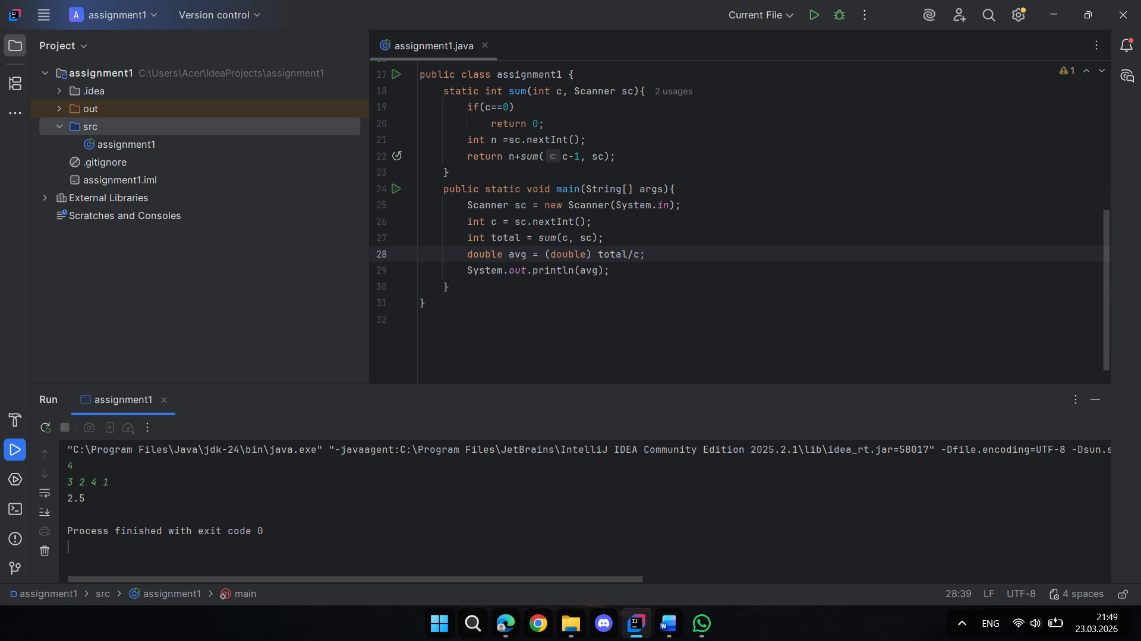

Task 3. Prime Number Check

Write a recursive function that checks whether a number n is prime. A prime number is a number that is divisible only by 1 and itself.

Example:
Input | Output
7 | Prime
10 | Composite

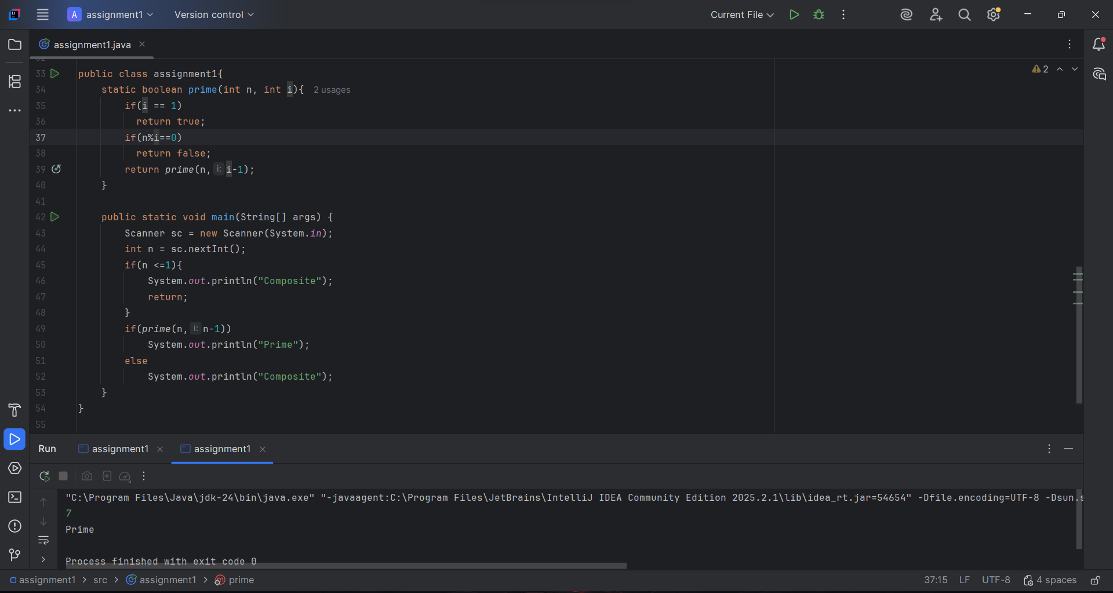
Task 4. Factorial

Write a recursive function that calculates n! (factorial).

Example:
Input | Output
5 | 120

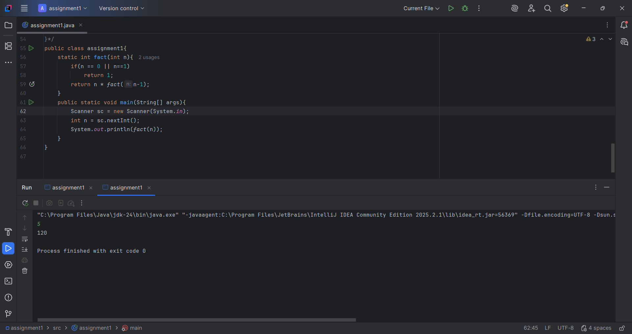
Part 2. Recursion with Sequences

Task 5. Fibonacci Number

Write a recursive function to find the n-th Fibonacci number.
Formula:
$$F_{n}=F_{n-1}+F_{n-2}$$

Base cases:
$F_{0}=0,F_{1}=1$

Example:

Input | Output
5 | 5
17 | 1597

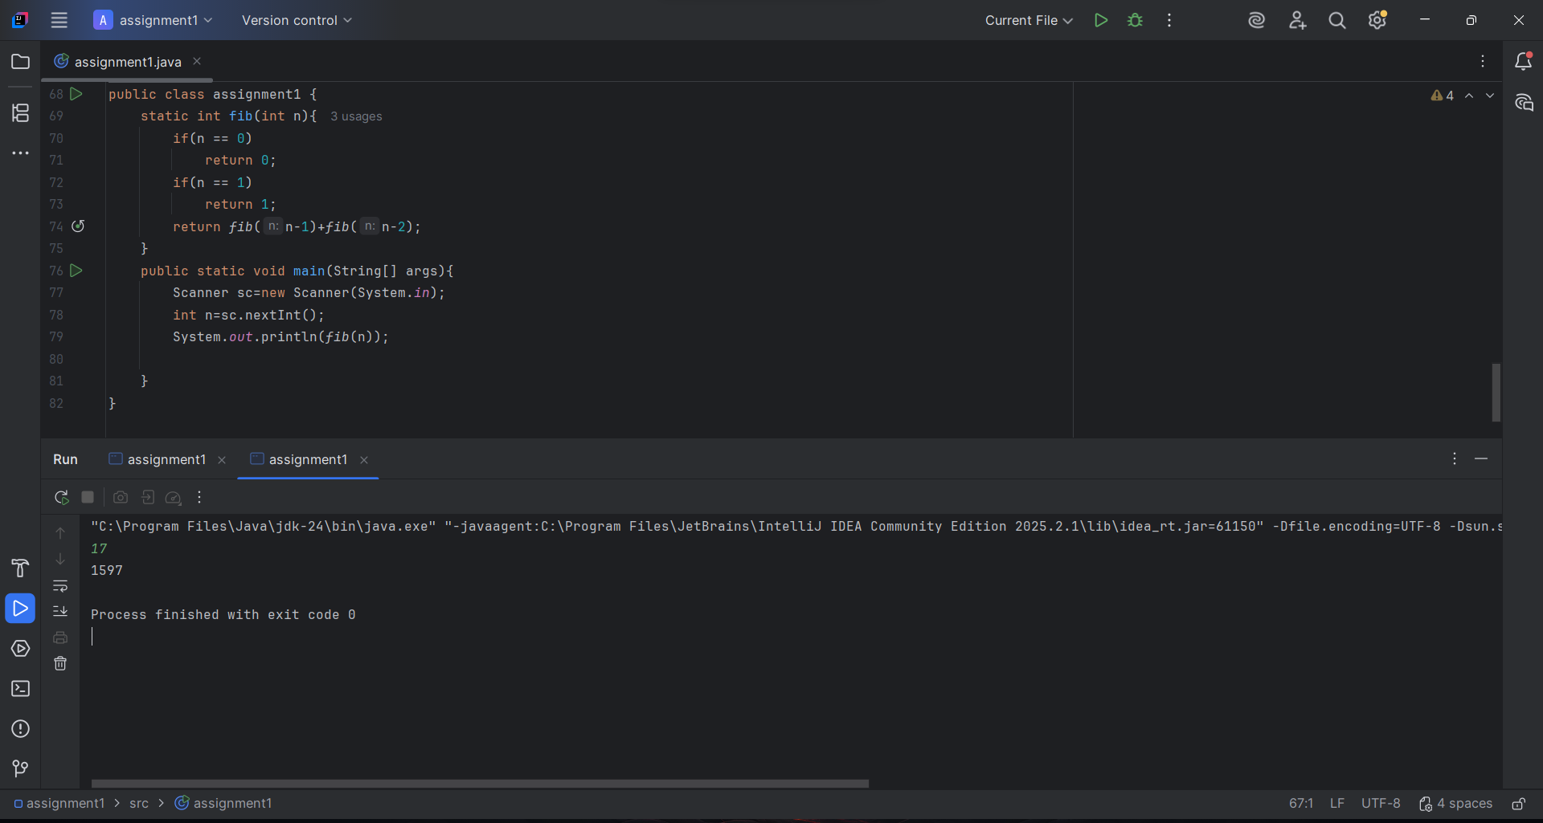
Task 6. Power Function

You are given numbers a and n. Write a recursive function that returns:
$a^{n}$

Example
Input | Output
2 10 | 1024

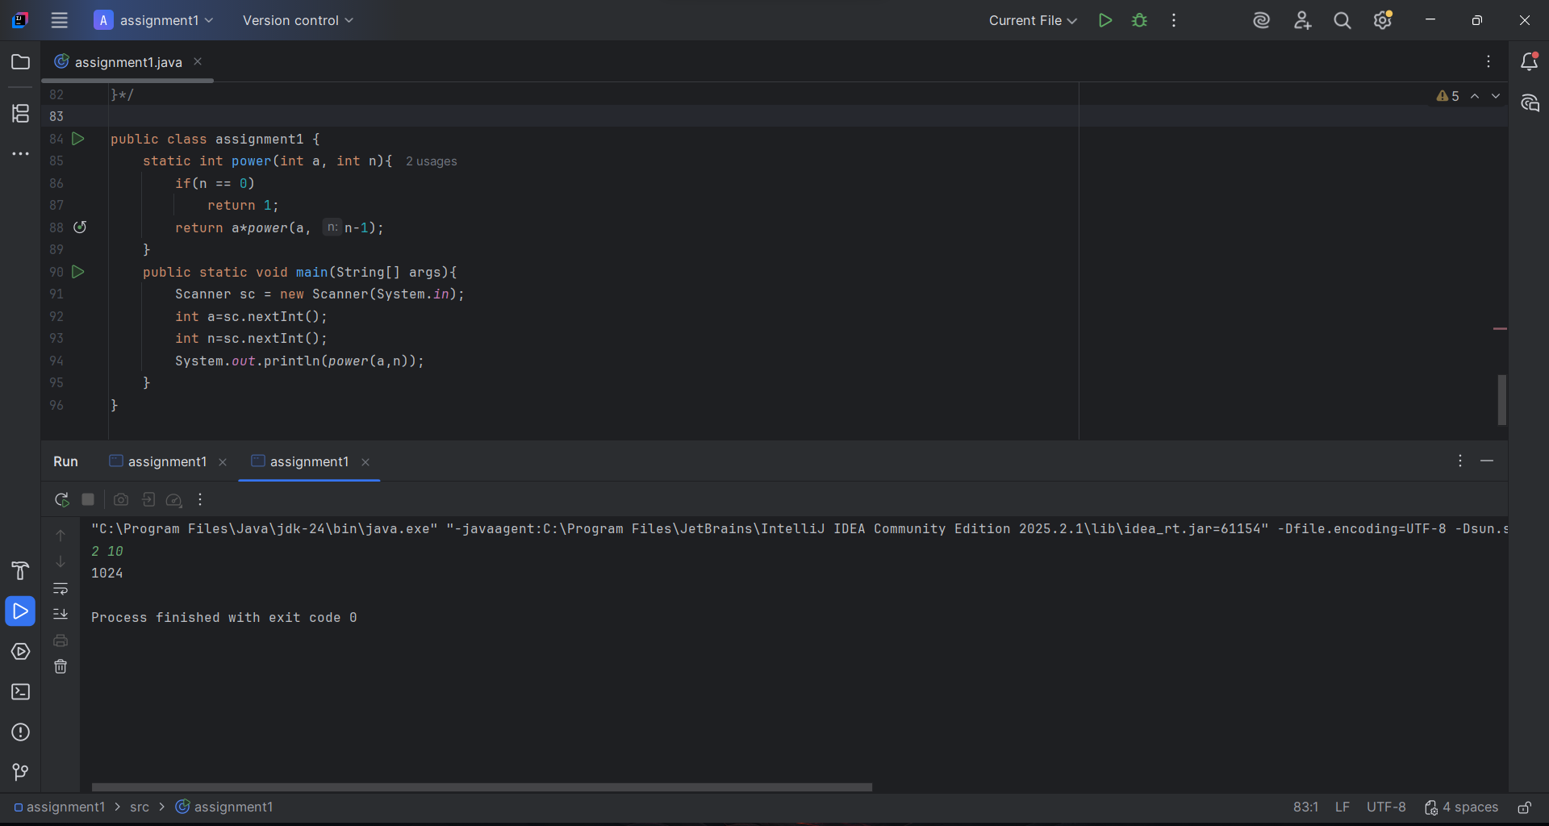

Task 7. Reverse Output

You are given n numbers. Write a recursive function that reads and prints the numbers in reverse order without using another array.

Example
Input | Output
4  1 4 6 2 | 2 6 4 1

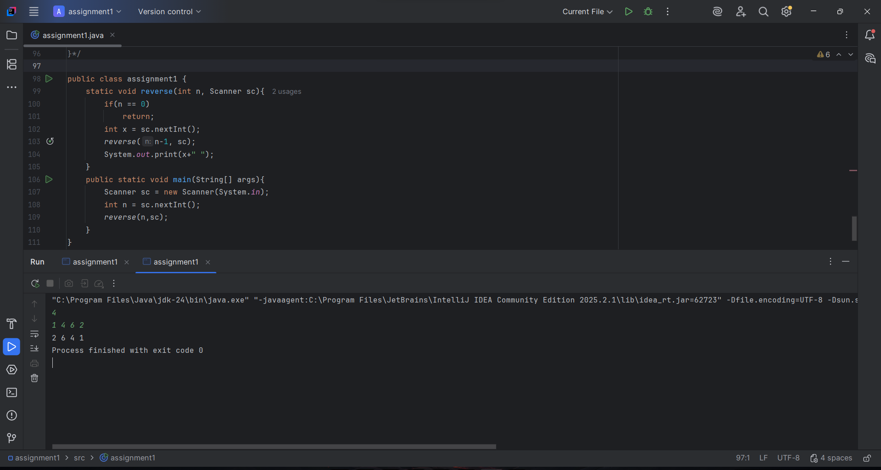
Part 3. Recursion with Strings

Task 8. Check Digits in String

You are given a string s. Write a recursive function that checks whether the string contains only digits. Return "Yes" if all characters are digits, otherwise return "No".

Example:
Input | Output
123456 | Yes
123a12 | No

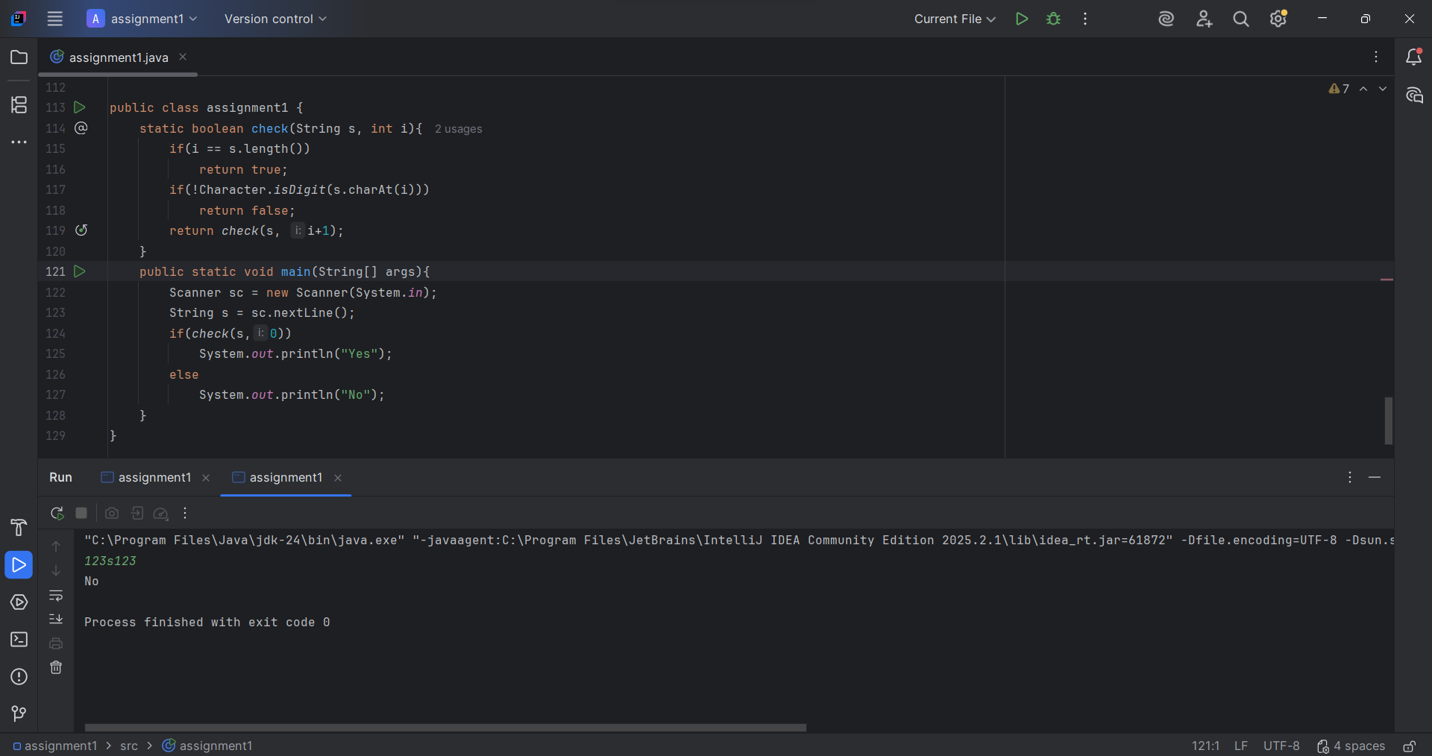
Task 9. Count Characters in a String

Write a recursive function that counts the number of characters in a given string. The function should return the total number of characters in the string.

Example:
Input | Output
hello | 5
recursion | 9

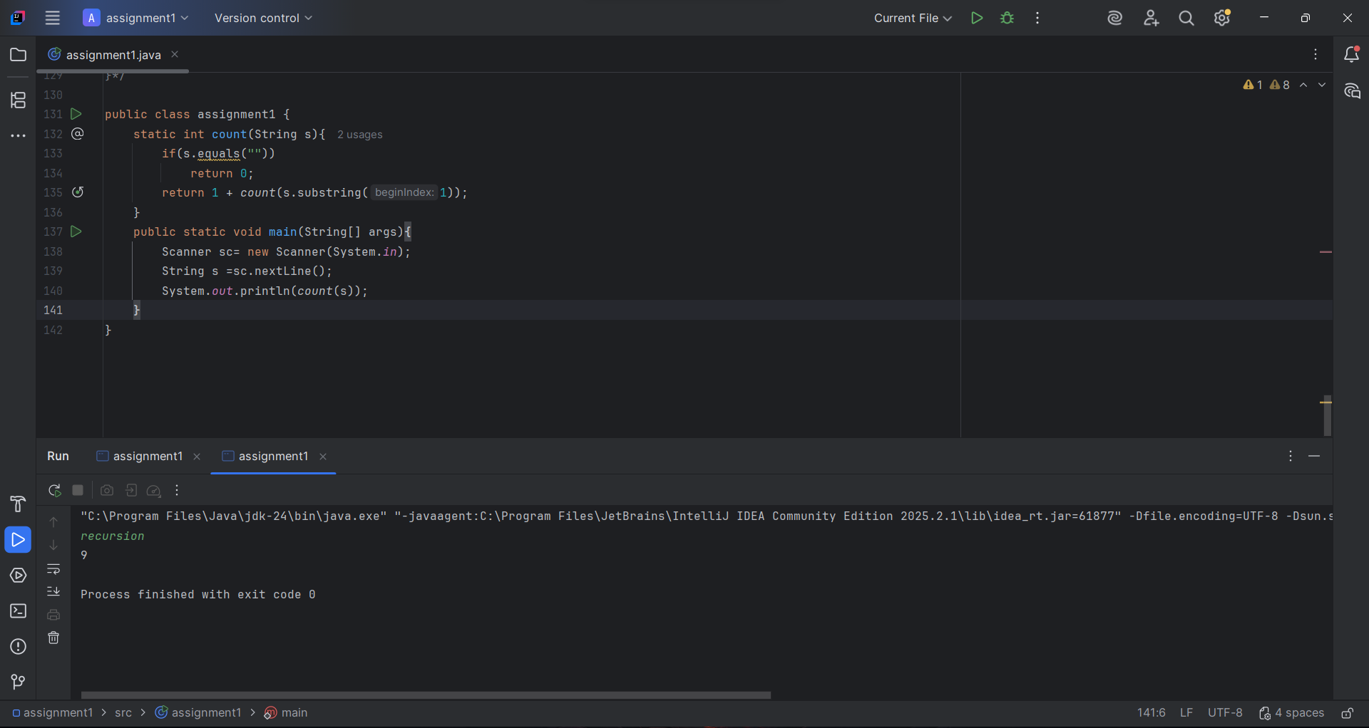
Task 10. Greatest Common Divisor (GCD)

Write a recursive function that finds the GCD of two numbers using the Euclidean Algorithm.

Example:
Input | Output
32 48 | 16
10 7 | 1

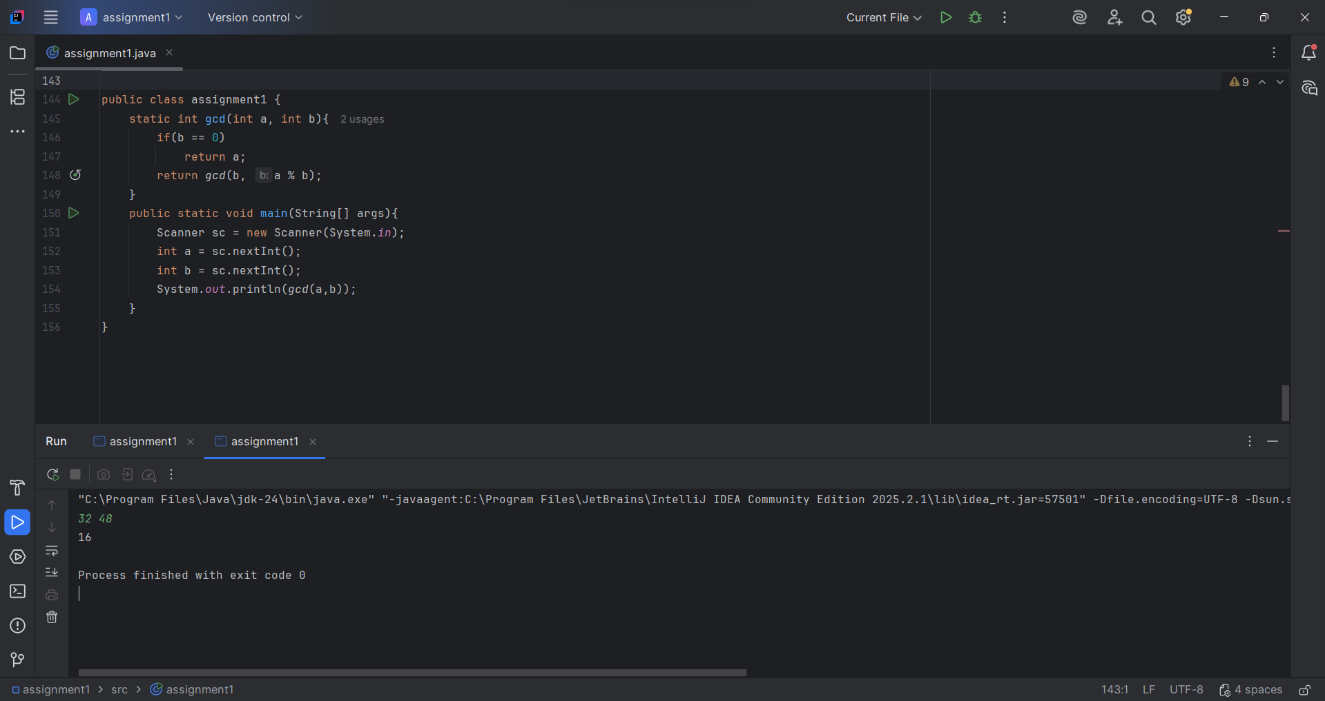

Evaluation Criteria (100 points total):

- Functionality (20 points):
  - The program compiles and runs without errors.
  - All recursive functions produce correct outputs for the given examples.
  - The program handles input and output correctly.

Code Quality (10 points):
  - Code is well-organized and readable
  - Proper naming of variables and functions.
  - Code indentation and formatting are clear.

Recursion Implementation (20 points):
  - All tasks are implemented using recursion only.
  - Correct base cases and recursive calls are used.
  - Loops (for, while, do-while) are not used.

Defense during Practice Lesson (40 points):
  - Student clearly explains the recursive logic used in their code.
  - Demonstrates the program working correctly.
  - Shows understanding of base cases and recursive calls.
  - Answers instructor’s questions confidently.

Report (10 points):
  - Report includes student name and group.
  - Contains screenshots of program outputs for each task.
  - Brief explanation of how the problems were solved.

Resources:

- Aditya Y. Bhargava, Grokking Algorithms, Manning Publications; 2nd edition, 2024
- https://www.youtube.com/watch?v=84QIO2a9taQ&list=PL38UDqoToqPRGSFnF5ySl6dP7nO_iLoLR&index=21
- https://www.youtube.com/watch?v=6HJFJL8mwvE&list=PL38UDqoToqPRGSFnF5ySl6dP7nO_iLoLR&index=22
- https://www.youtube.com/watch?v=KfEG-QsciFU&list=PL38UDqoToqPRGSFnF5ySl6dP7nO_iLoLR&index=1
- https://www.youtube.com/watch?v=6Pw3sf0lWME&list=PL38UDqoToqPRGSFnF5ySl6dP7nO_iLoLR&index=3
- https://www.w3schools.com/java/java_recursion.asp
**Questions will be based on the provided resources

Good luck!

